**UNIT 1**

**TALEND**

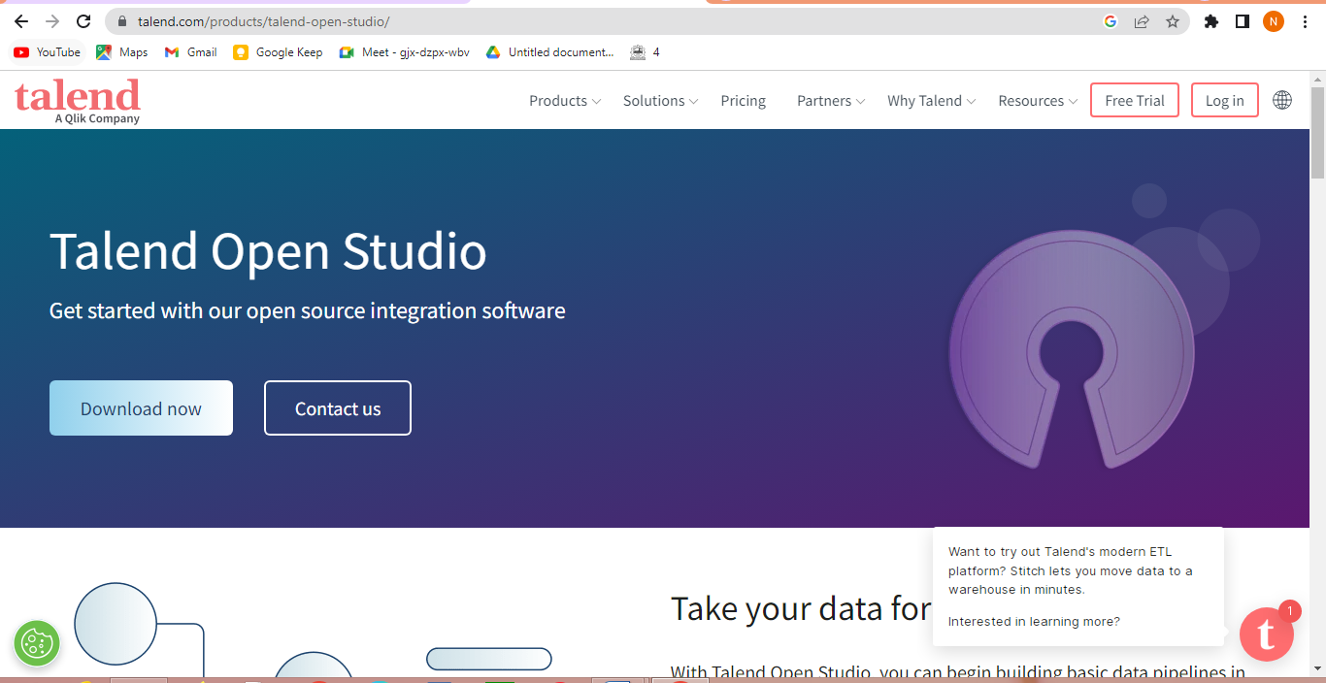**Link -** [**https://www.talend.com/products/talend-open-studio/**](https://www.talend.com/products/talend-open-studio/)

Talend is a global software company that provides data integration and data management solutions. The company's products are used by businesses of all sizes to connect, access, and transform data from a variety of sources. Talend's solutions are designed to help businesses improve their data quality, reduce their data integration costs, and accelerate their time to market.

Talend was founded in 2005 by Bertrand Delacretaz, Lionel Henry, and Jean-Michel Edard. The company is headquartered in Paris, France, and has offices in over 30 countries. Talend's products are used by businesses in a wide range of industries, including financial services, healthcare, retail, and manufacturing.

Talend's flagship product is Talend Open Studio, an open-source ETL tool that allows users to connect, transform, and load data from a variety of sources. Talend Open Studio is a popular tool for data integration, and it is used by businesses of all sizes.

In addition to Talend Open Studio, Talend also offers a number of other products, including:

* Talend Data Fabric: A comprehensive data management platform that provides solutions for data integration, data quality, and data governance.
* Talend Cloud: A cloud-based platform that offers a variety of data integration and data management services.
* Talend Academy: A free online training platform that offers courses on Talend's products and technologies.

Talend is a leading provider of data integration and data management solutions. The company's products are used by businesses of all sizes to improve their data quality, reduce their data integration costs, and accelerate their time to market. Talend is committed to helping businesses get the most value from their data.

Here are some of the benefits of using Talend:

* Scalability: Talend's products are scalable to meet the needs of businesses of all sizes.
* Ease of use: Talend's products are easy to use, even for those with no prior experience with data integration.
* Extensibility: Talend's products are extensible, so businesses can customize them to meet their specific needs.
* Support: Talend offers extensive support for its products, including online documentation, training, and technical support.

If you are looking for a data integration or data management solution, Talend is a good option to consider. The company's products are scalable, easy to use, extensible, and well-supported. Talend can help you improve your data quality, reduce your data integration costs, and accelerate your time to market. Here are some of the industries that use Talend:

* Financial services: Talend's products are used by financial institutions to integrate data from a variety of sources, such as customer records, transaction data, and market data.
* Healthcare: Talend's products are used by healthcare organizations to integrate data from a variety of sources, such as electronic health records, medical imaging data, and patient surveys.
* Retail: Talend's products are used by retailers to integrate data from a variety of sources, such as point-of-sale data, inventory data, and customer loyalty data.
* Manufacturing: Talend's products are used by manufacturers to integrate data from a variety of sources, such as production data, quality control data, and supply chain data.

**UNIT 2**

**LUMIFY**

**LINK -** [**https://vulners.com/n0where/N0WHERE:76359\**](https://vulners.com/n0where/N0WHERE:76359\)

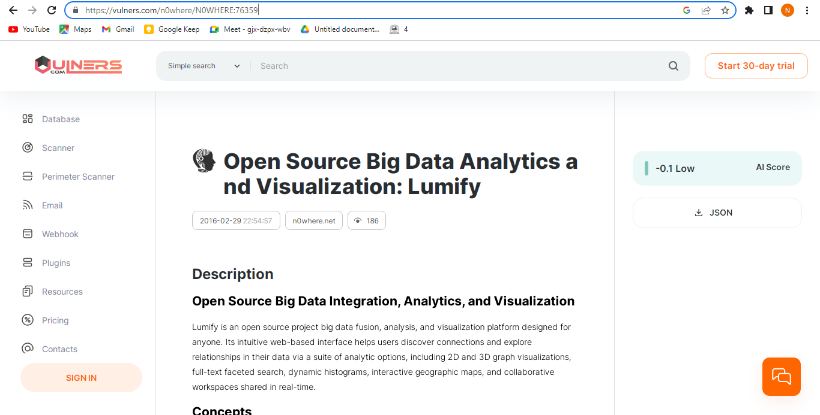

Lumify is an open-source big data platform that enables organizations to gain insights from large data sets. The platform offers a variety of features that make it easy to work with big data, including support for multiple data sources, a user-friendly interface, and a powerful graph analytics engine.

Lumify is built on top of Apache Hadoop and Apache Spark, two of the most popular big data platforms. This means that Lumify can be used to process and analyze large data sets that would be too big for traditional data processing systems.

Lumify's user-friendly interface makes it easy to explore and visualize data. The platform includes a variety of visualization tools that can be used to create interactive dashboards and reports.

Lumify's graph analytics engine is used to identify relationships between entities in a data set. This can be used to discover patterns and trends that would not be visible with traditional data analysis methods.

Lumify is a powerful big data platform that can be used to gain insights from large data sets. The platform is easy to use and includes a variety of features that make it a valuable tool for data analysts and researchers.

Here are some of the key features of Lumify:

* Support for multiple data sources: Lumify can be used to process data from a variety of sources, including Hadoop, Spark, relational databases, and NoSQL databases.
* User-friendly interface: Lumify's user interface is designed to be easy to use, even for those with no prior experience with big data.
* Powerful graph analytics engine: Lumify's graph analytics engine can be used to identify relationships between entities in a data set.
* Extensibility: Lumify is extensible, so users can customize the platform to meet their specific needs.
* Open source: Lumify is open source, so it is free to use and modify.

Lumify is a versatile big data platform that can be used for a variety of purposes. The platform is used by businesses, government agencies, and educational institutions to gain insights from large data sets.

Here are some of the industries that use Lumify:

* Financial services: Lumify is used by financial institutions to analyze financial data and identify fraud.
* Healthcare: Lumify is used by healthcare organizations to analyze patient data and improve patient care.
* Retail: Lumify is used by retailers to analyze customer data and improve marketing campaigns.
* Manufacturing: Lumify is used by manufacturers to analyze production data and improve quality control.

**UNIT 3**

**KNIME**

**LINK -** [**https://www.knime.com/knime-analytics-platform**](https://www.knime.com/knime-analytics-platform)

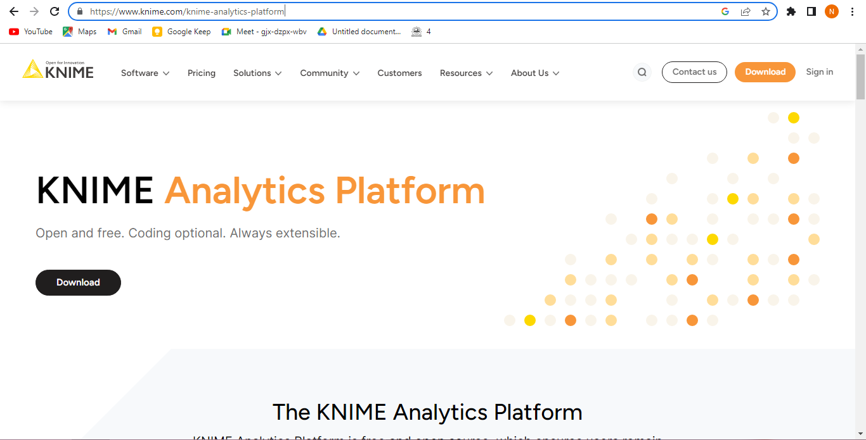

KNIME is an open-source, visual data science platform that enables users to connect, analyze, and visualize data. The platform is built on top of Eclipse and uses a graphical user interface (GUI) to create data workflows. KNIME is a popular tool for data scientists, researchers, and business analysts.

KNIME offers a variety of features that make it a powerful big data platform. These features include:

* Support for multiple data sources: KNIME can be used to connect to a variety of data sources, including relational databases, NoSQL databases, cloud storage, and flat files.
* Visual data workflow: KNIME's graphical user interface makes it easy to create data workflows. These workflows can be used to connect data sources, apply data transformations, and create visualizations.
* Wide range of data processing nodes: KNIME offers a wide range of data processing nodes that can be used to perform a variety of tasks, such as data cleaning, data transformation, machine learning, and visualization.
* Extensibility: KNIME is extensible, so users can create their own nodes or add plugins to extend the platform's functionality.
* Community: KNIME has a large and active community that provides support and resources to users.

KNIME is a versatile big data platform that can be used for a variety of purposes. The platform is used by businesses, government agencies, and educational institutions to gain insights from large data sets.

Here are some of the industries that use KNIME:

* Financial services: KNIME is used by financial institutions to analyze financial data and identify fraud.
* Healthcare: KNIME is used by healthcare organizations to analyze patient data and improve patient care.
* Retail: KNIME is used by retailers to analyze customer data and improve marketing campaigns.
* Manufacturing: KNIME is used by manufacturers to analyze production data and improve quality control.

If you are looking for a big data platform that is easy to use, powerful, and extensible, KNIME is a good option to consider. The platform is free to use and modify, so you can customize it to meet your specific needs.

Here are some of the benefits of using KNIME:

* Ease of use: KNIME's graphical user interface makes it easy to create data workflows. Even users with no prior experience with data science can use KNIME to gain insights from data.
* Powerful: KNIME offers a wide range of data processing nodes that can be used to perform a variety of tasks. This makes KNIME a powerful tool for data analysis and machine learning.
* Extensible: KNIME is extensible, so users can create their own nodes or add plugins to extend the platform's functionality. This makes KNIME a versatile tool that can be used for a variety of purposes.
* Community: KNIME has a large and active community that provides support and resources to users. This makes KNIME a valuable resource for learning about data science and machine learning.

**UNIT 4**

**Apache Drill**

**LINK -** [**https://drill.apache.org/**](https://drill.apache.org/)

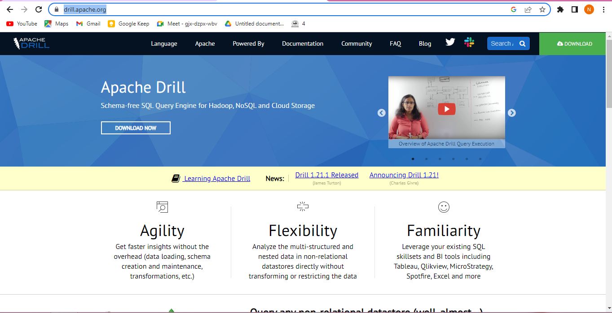

Apache Drill is an open-source, distributed SQL query engine for large-scale data exploration. Drill is designed to be fast, easy to use, and scalable. It can be used to query data from a variety of sources, including Hadoop, NoSQL databases, and cloud storage.

Drill is a columnar query engine, which means that it stores data in columns rather than rows. This makes it more efficient for querying large data sets. Drill also supports a variety of features that make it easy to use, such as schema-less querying and ad-hoc queries.

Drill is a scalable query engine. It can be deployed on a single machine or on a cluster of machines. Drill is also designed to be fault-tolerant. If a node in the cluster fails, Drill will automatically re-balance the workload.

Drill is a powerful tool for data exploration. It can be used to query data from a variety of sources and to perform complex queries. Drill is also easy to use, making it a good choice for both experienced and inexperienced users.

Here are some of the key features of Apache Drill:

* Fast: Drill is designed to be fast. It can query large data sets quickly.
* Easy to use: Drill is easy to use. It can be used by both experienced and inexperienced users.
* Scalable: Drill is scalable. It can be deployed on a single machine or on a cluster of machines.
* Fault-tolerant: Drill is fault-tolerant. If a node in the cluster fails, Drill will automatically re-balance the workload.
* Supports a variety of data sources: Drill can query data from a variety of sources, including Hadoop, NoSQL databases, and cloud storage.
* Supports a variety of features: Drill supports a variety of features, such as schema-less querying and ad-hoc queries.

Apache Drill is a powerful tool for data exploration. It is fast, easy to use, scalable, and fault-tolerant. Drill can be used to query data from a variety of sources and to perform complex queries. Drill is a good choice for both experienced and inexperienced users.

**UNIT 5**

**Pentaho**

**LINK - <https://www.hitachivantara.com/en-us/products/pentaho-platform/data-integration-analytics.html>**

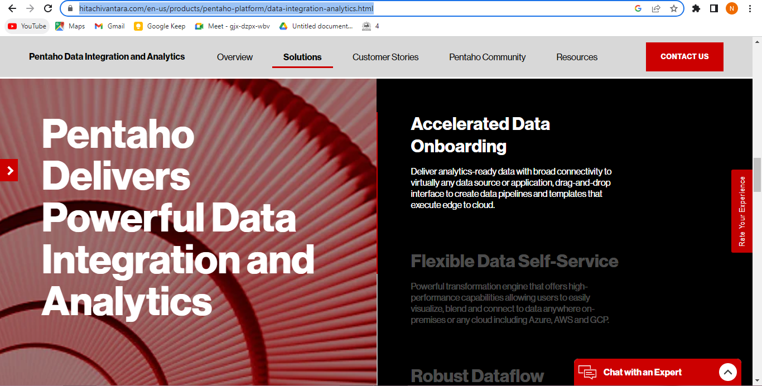

Pentaho is a business intelligence (BI) platform that provides data integration, data mining, and reporting capabilities. The platform is used by businesses of all sizes to improve their data quality, reduce their data integration costs, and accelerate their time to market.

Pentaho was founded in 2004 by Doug Moran, James Dixon, Marc Batchelor, and Richard Daley. The company is headquartered in Orlando, Florida, and has offices in over 30 countries. Pentaho's products are used by businesses in a wide range of industries, including financial services, healthcare, retail, and manufacturing.

Pentaho's flagship product is Pentaho Data Integration (PDI), an open-source ETL tool that allows users to connect, transform, and load data from a variety of sources. Pentaho PDI is a popular tool for data integration, and it is used by businesses of all sizes.

In addition to Pentaho PDI, Pentaho also offers a number of other products, including:

* Pentaho Data Mining: A data mining tool that allows users to build and deploy data mining models.
* Pentaho Reporting: A reporting tool that allows users to create interactive reports.
* Pentaho BI Server: A BI server that allows users to share data and reports across an organization.
* Pentaho Data Integration Cloud: A cloud-based version of Pentaho PDI.

Pentaho is a leading provider of BI platforms. The company's products are used by businesses of all sizes to improve their data quality, reduce their data integration costs, and accelerate their time to market. Pentaho is committed to helping businesses get the most value from their data.

Here are some of the benefits of using Pentaho:

* Open source: Pentaho is open source, which means that it is free to use and modify.
* Scalable: Pentaho is scalable, so it can be used by businesses of all sizes.
* Easy to use: Pentaho is easy to use, even for those with no prior experience with BI tools.
* Extensible: Pentaho is extensible, so users can customize the platform to meet their specific needs.
* Support: Pentaho offers extensive support for its products, including online documentation, training, and technical support.

If you are looking for a BI platform that is open source, scalable, easy to use, extensible, and well-supported, Pentaho is a good option to consider. Pentaho can help you improve your data quality, reduce your data integration costs, and accelerate your time to market. Here are some of the industries that use Pentaho:

* Financial services: Pentaho's products are used by financial institutions to integrate data from a variety of sources, such as customer records, transaction data, and market data.
* Healthcare: Pentaho's products are used by healthcare organizations to integrate data from a variety of sources, such as electronic health records, medical imaging data, and patient surveys.
* Retail: Pentaho's products are used by retailers to integrate data from a variety of sources, such as point-of-sale data, inventory data, and customer loyalty data.
* Manufacturing: Pentaho's products are used by manufacturers to integrate data from a variety of sources, such as production data, quality control data, and supply chain data.